Badji Mokhtar University - Annaba - Faculty of Sciences - Department of Life and Natural Sciences

The year : 1st year 2019/2020

The field : Biology

The module : Techniques de Communication et d'Expression / Anglais/

**BACTERIA AND VIRUSES**

**( 4 : Grammar Focus : Connctors / Linking Words)**

**1-WHAT IS A BACTERIUM ?**

A bacterium is a **microscopic** , single-celled organisms that thrives in diverse environments .These organisms can live in soil , the ocean and inside the human gut.

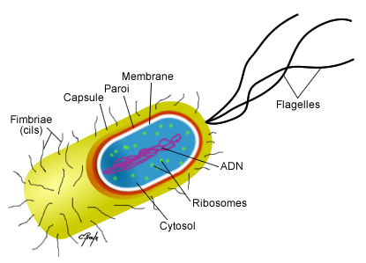

Figure 1: Structure of a bacterium .

**2- WHAT IS A VIRUS ?**

A virus is a small **infectious** agent that replicates only inside the living cells of an organism . They can affect all types of life forms , from animals and plants to microoganisms inlcuding bacteria and **archaea** .

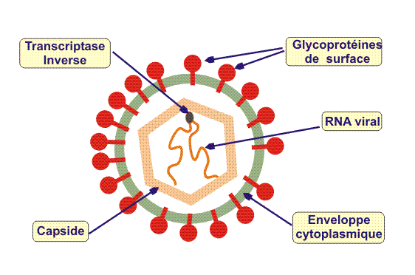

Figure 2: structure of a virus .

**3- HOW DO VIRUSES DIFFER FROM BACTERIA?**

Viruses ( Like those that cause the flu , or cold , or AIDS) are not made of cells . Although viruses make you sick , just like bacteria do , viruses and bacteria are actually quite different. Viruses are simpler than bacteria and are made of just few molecules . In fact , viruses have so few parts that they can not even grow and divide by themselves ( so they are not considered to be alive). Viruses can only reproduce if they take **a host cell** and steal its energy and materials .