Badji Mokhtar University - Annaba - Faculty of Sciences - Department of Life and Natural Sciences

The year : 1st year 2019/2020

The field : Biology

The module : Techniques de Communication et d'Expression / Anglais/

**A GENERAL INTRODUCTION TO BIOLOGY**

(1-Grammar Focus : The Present Simple / The Past Simple)

**1- WHAT IS BIOLOGY ?**

It is the scientific study of **living things** including humans , animals and plants .

**2- ETHYMOLOGY OF THE WORD :**

Biology comes from the two Greek words : 'Bios' which means 'Life' , and 'Logy' meaning 'The study of ' .

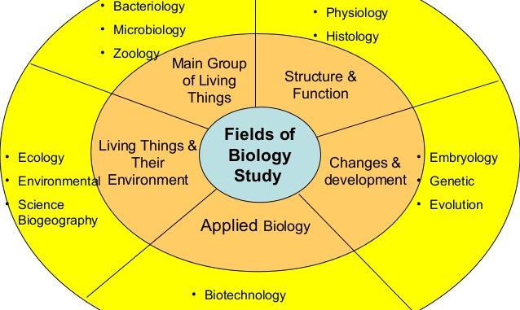

Figure 1 : The scopes of Biology

**3- A BRIEF HISTORY ABOUT THE DEVELOPMENT OF BIOLOGY :**

The German naturalistic ‘ Treviranus ‘ was the first one to use the term Biology in 1802 .In his writing established , he defined this field as a domain containing the different phenomena and forms of life , the conditions that govern their existence and the causes that determine their activites.

The exact begenning of the biology is still unknown . Throught history , many civilisations have achieved this domain and developped many aspects . The following table will explain the main civilisations and their acheivements

|  |  |
| --- | --- |
| 1. The babylonians | They learned that the date palm reproduces sexually and that pollen could be taken from the male plant and used to fertilize female plants. |
| 1. The Egyptians | Their well-preserved mummies show that they had a through understanding of the preservative properties of herbs required for embalming . |
| 1. The Greek/ Romans | The Greek philosophers thought that every event has a cause , and that a particular cause produces a particular consequence. That concept known as ‘ Causality ‘ had a profound effect of the scientific investigation. Hence , their gratest contribution is the idea of rational thought. |

**4-THE FIELDS OF THE STUDY OF BIOLOGY :**

Biology has many fields of study such as Ecology , Zoology and Physiology The followings are the ones available in Badji Mokhtar University :

* **Biological sciences** : they contain many sub-fields , such as vegetal biology , animal biology , Microbiolgy , Biochemistery , Toxicology ,
* **Ecology** , the branch that deals with the relations of organisms to one another and to their physical surroundings
* **Marine biology** :the scientif study of marine life , organisms in the sea
* **Biotechnology**: the exploitation of biological processes for undestrial and other purposes