Badji Mokhtar University - Annaba - Faculty of Sciences - Department of Life and Natural Sciences

The year : 1st year 2019/2020

The field : Biology

The module : Techniques de Communication et d'Expression / Anglais/

**THE ECOSYSTEM**

(5- Grammar Focus : Nominalisation )

**1-WHAT IS AN ECOSYSTEM ?**

The ecosystem is a core concept in Biology and **Ecology** , serving as the level of biological organization in which organisms **interact** simultanesouly witch each other and with their environment . As such , ecosystems are a level above that of the ecological community (Organisms of different species interacting with each other but are at a level below , or equal to , **biomes** and **the biosphere**. It is a community of living organisms in conjunction with the non living components of their environment , interacting as a system .

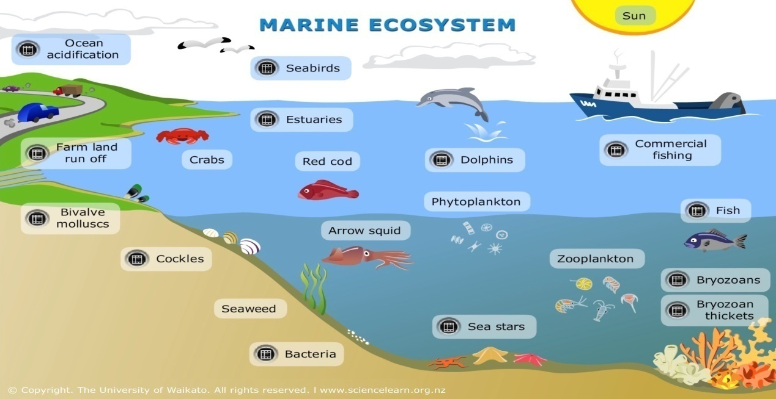

Figure 1 : A sample of a Marine Ecosystem .

**2-THE COMPONENTS OF AN ECOSYSTEM :**

we can clarify the parts of an ecosystem by listing them under two categories which are the ' abiotic ' and ' biotic' components.

The abiotic components of an ecosystem are all of the non living elements . They include the water , the air ,the temperature , the rocks and minerals that make up the soil.

The biotic components of an ecosystem include the living things which interact with the abiotic components .

**3- WHAT HAPPENS INSIDE THE ECOSYSTEM ?**

Energy enters the biological system as light energy , or **photons** ,and then is transofmred into chemical energy in organic molecules by cellular processes including **photosyntheses** and respiration , and ultimately is converted to heat energy . This energy is dissipated ,meaning it is lost , to the system as heat . Once it is lost , it can not be recycled . Without the coninued **input** of solar energy , biologycal systems would quickly shut down . Thus , the earth is an open system with respect to energy .