Badji Mokhtar University - Annaba - Faculty of Sciences - Department of Life and Natural Sciences

The year : 1st year 2019/2020

The field : Biology

The module : Techniques de Communication et d'Expression / Anglais/

**CELL OVERVIEW**

( 2- Grammar Focus : Active and Passive Voice)

**1-WHAT IS A CELL ?**

Cells are sacs of **fluid** that are reinforced by proteins and surrounded by **membranes** . Inside the fluid float chemicals and organelles , structures inside cells that are used during metabolic processes . (An organism contains parts that are smaller than a cell , but these structures can not perform all the functions of life on their own , so they are not considered alive ). A cell is the smallest part of an organism that retains characterestics of the entire organism . For example , a cell can take in **fuel** , convert it to energy , and eliminate wastes , jult like the organism as whole can .

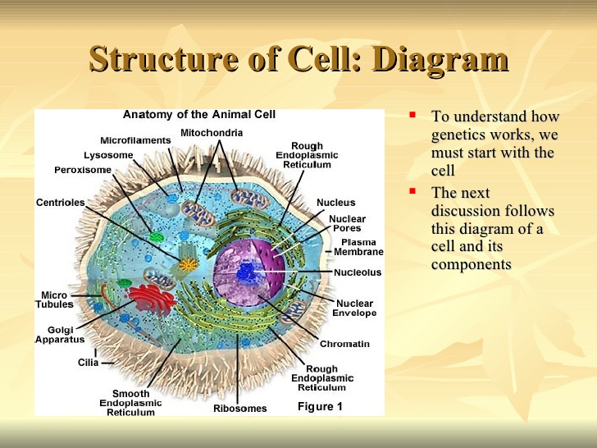

Figure 1 : Structure of a cell .

**2-TYPES OF CELLS :**

Cells are categorized in different ways , according to structure or function , or in terms of their evolutionary relationship . In term of structure , scientists categorize cells based on their internal organization :

PROKARYOTES : They do not have a 'true' **nucleus** in their cells like Bacteria and archaea .

EUKARYOTES : They have a nucleus in their cells that houses their genetic material , like plants , animals agae..