**SII: Lesson 2: *Antigone***

**I- The Elements of Drama**

|  |  |  |
| --- | --- | --- |
|  | **Drama**, also known as a **play**, is a form of literature written intentionally for **theatrical** **performance**. There are **main** **elements** of drama which serve as the basis of producing a successful play.  **1. Plot**   |  | | --- | | Résultat de recherche d'images pour "plot diagram" |   **Plot**, referring to the **basic storyline** of the play, is the structure of a play which tells what happens as the story goes. The plot structure can be divided into **5** main **stages**: exposition, rising action, climax, falling action, and resolution.   1. **Exposition** — It is the **opening** of the story, including an introduction to characters and settings. 2. **Rising Action** — It is a series of events that **complicates** matters for the characters and results in increased suspense. 3. **Climax** — It is the turning point, or the **peak**, of a plot where the characters encounter their opposition, and either win or lose. 4. **Falling Action** — It is a series of events following the climax that **leads** to the **solution** of the conflicts. 5. **Resolution (**also called **denouement)** — It is the **end** of the story, in which the **problems** are resolved (or not resolved, depending on the story).   **2. Character**  **Characters** are the **people**, or sometimes **animals** that are portrayed by the **actors** and **actresses** in the play. They can be categorized into **three** **types** according to the roles they play. The main character of the play is known as the **protagonist**. The **antagonist** is the character who opposes the protagonist. The other characters are called the **secondary** **characters**.  **3. Setting**  The **setting** is the **place** and the **time** in which the events occur. The setting in the drama can be enhanced by using viewable elements, sound effects, and music.  **4. Theme**  The **theme** refers to the **main idea** or the **lesson** to be learned from the play.  **5. Audience**  **Audience** is a **group** of **people** who **watch** the play. Audience can be said to be the most **important** element of drama since it is the audience that **determines** whether the play is successful or not. |
|  |  |

**II- The Tragedy of Sophocles: *Antigone***

**\*Sophocles** (**496**-**406** **B.C.**) was a famous **ancient Greek** **writer** who wrote over 100 **plays**. He was the author of seven surviving **plays**, including ***Antigone***, which is believed to have been **written** in the **5th century** **BC**.

\***Summary of *Antigone*** (a **Play** written by Sophocles)

In Thebes, [Creon](https://www.gradesaver.com/mythology/study-guide/character-list#creon) becomes king, but [Polyneices](https://www.gradesaver.com/mythology/study-guide/character-list#polyneices), Oedipus's son, and his allies wage war against him. Oedipus’s other son [Eteocles](https://www.gradesaver.com/mythology/study-guide/character-list#eteocles) defends Thebes, and in the fighting, the two brothers kill each other, according to the curse of Oedipus, their father. After the bloody siege of Thebes by Polyneices, the city stands unconquered. Outside the city gates, Antigone tells Ismene that Creon has ordered that Eteocles, who died defending the city, is to be buried with full honors while the body of Polyneices, the traitor, is left to rot. Furthermore, Creon has declared that anyone attempting to bury Polyneices shall be publicly stoned to death. Outraged, Antigone reveals to Ismene a plan to bury Polyneices in secret, despite Creon's order. When Ismene timidly refuses to defy the king, Antigone angrily rejects her and goes off alone to bury her brother. Creon discovers that someone has attempted to offer a ritual burial to Polyneices and demands that the guilty one be found and brought before him. When he discovers that Antigone, his niece, has defied his order, Creon gets furious. Antigone declares Creon's order to be against the laws of the gods themselves. She draws attention to the difference between divine law and human law. Enraged by Antigone's refusal to submit to his authority, Creon declares that she and her sister will be put to death. Haemon, Creon's son who was to marry Antigone, advises his father to reconsider his decision. The father and son argue, Haemon accusing Creon of arrogance, and Creon accusing Haemon of unmanly weakness in siding with a woman. Haemon leaves in anger, swearing never to return. Without admitting that Haemon may be right, Creon amends his pronouncement on the sisters: Ismene shall live, and Antigone will be sealed in a tomb to die of starvation, rather than stoned to death by the city. The blind prophet Teiresias warns Creon that the gods disapprove of his leaving Polyneices unburied and will punish the king's impiety with the death of his own son. After rejecting Teiresias angrily, Creon reconsiders and decides to bury Polyneices and free Antigone, but his change of heart comes too late. Antigone has hanged herself and Haemon, in desperate agony, kills himself as well. On hearing the news of her son's death, Eurydice, the queen, also kills herself, cursing Creon. Alone, in despair, Creon accepts responsibility for all the tragedy and prays for a quick death. The play ends with a somber warning from the chorus that pride will be punished by the blows of fate.

(The **curse** of **Oedipus**: **Oedipus** was king of Thebes, a city in central Greece. He is famous in Greek myth for unknowingly killing his father (Laius) and marrying his mother (Jocasta). Realizing that he has unwittingly fulfilled a curse that he would kill his father and marry his mother, Oedipus blinds himself and becomes a wanderer Oedipus dies before the action of Sophocles’ play Antigone begins, but his curse impacts his descendants.)

\***Main Characters**

**Antigone:** Antigone is the protagonist of the play. She is Oedipus's daughter and the niece of Creon, who isthe new king of Thebes. Antigone is also engaged to Creon'sson, Haemon. She defies Creon's order that her brotherPolyneices's body remain unburied even though thepunishment is death because she believes that it is unjust.

**Ismene:** Ismene, Antigone's sister, refuses to help Antigone bury their brother for fear of the punishment attached to disobeyingCreon's orders.

**Creon:** Creon is the antagosnist. He is Antigone and Ismene's uncle andHaemon's father. He is also the newly appointed king ofThebes, and he believes that his laws are the ultimateauthority. He disagrees with Antigone's justifications for burying her brother, and his arrogance results in the deaths of everyone he loves.

**Haemon:** Haemon is Creon's son, and he is also engaged to Antigone. He tries to advise him to be lenient with Antigonesince the citizens of Thebes do not support his decision.Haemon dies by his ownhand, angry over Antigone's death.

**Chorus:** A group of singers that offers narration and judgments about the characters' actions.

**Eteocles:** Eteocles is the youngest son of Oedipus and brother to Antigone and Ismene; he is killed in a battle over the throne of Thebes against his brother Polyneices.

**Eurydice:** Eurydice is Creon's wife and Haemon's mother.

**Polyneices:** Polyneices is the oldest son of Oedipus and brother to Antigone and Ismene; he is killed in a battle over the throne of Thebes against his brother Eteocles.

**Teiresias:** Teiresias is a blind prophet who warns Creon about his fate.

|  |
| --- |
|  |

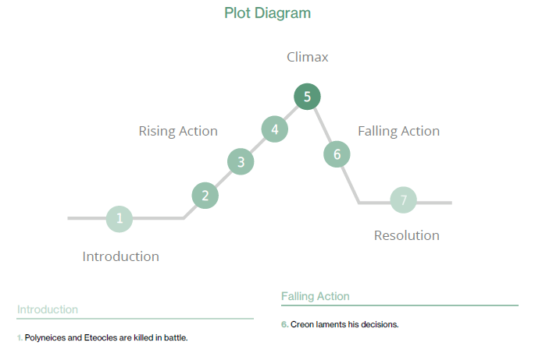

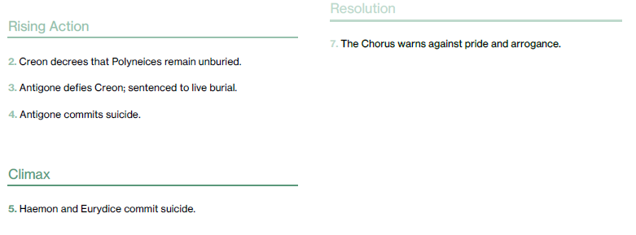

\***Themes**

**Natural Law**

[**Creon**](https://www.litcharts.com/lit/antigone/characters/creon), as head of state and lawgiver in Thebes, believes in obedience to **man-made** **laws**. But in defying Creon's command that no one should bury Polyneices, [**Antigone**](https://www.litcharts.com/lit/antigone/characters/antigone) appeals to a different set of guidelines—what is often called “**natural law**.” Antigone believes that the gods have commanded people to give the dead a proper burial. She also believes that she has a greater loyalty to her brother in performing his burial rites than she does to the law of the city of Thebes that bans her from doing so. The wishes of the gods and her sense of duty to her brother are both examples of **natural law** that **outweighs** any **human laws**. In *Antigone*, Sophocles explores this tension and seems to suggest—through Antigone's martyrdom, the people's sympathy, and Creon's downfall—that the laws of the state should not contradict natural laws.

**Citizenship and Family Loyalty**

The concept of **citizenship** and the **duties** that citizens owe to the state were subjects of huge importance and debate in fifth-century B.C. Athens, where Sophocles lived and where *Antigone* was first performed. **Antigone** and **Creon** represent the extreme **opposite** political views regarding where a **citizen** of a city should place his or her **loyalties**. In the play, [**Creon**](https://www.litcharts.com/lit/antigone/characters/creon) has a strict definition of **citizenship** that calls for the **state** to come **first**: “…whoever places a friend / above the good of his country, he is nothing: / I have no use for him.” From Creon's perspective, Polyneices has lost the right to a proper burial as a citizen of Thebes because he has attacked the city, has shown his disloyalty to the state, and has ceased to be a citizen. In fact, Creon is more devoted to his laws than he is to even his own son Haemon's happiness, refusing to pardon [Antigone](https://www.litcharts.com/lit/antigone/characters/antigone) for burying Polyneices even though she is Haemon's fiancée. **Antigone**, on the other hand, places **traditions** and **loyalty** to her **family** **above** **obedience** to the city and to its ruler. In doing so, she makes the case that there are **loyalties** to both the **gods** and one's own **family** that **outweigh** one's **loyalty** to a **city**.

**Civil Disobedience**

[**Creon**](https://www.litcharts.com/lit/antigone/characters/creon) says that the **laws** enacted by the leader of the city “must be obeyed, large and small, / right and wrong.” In other words, Creon is arguing that the **law** is the **basis** for **justice**, so there can be no such thing as an unjust law. [**Antigone**](https://www.litcharts.com/lit/antigone/characters/antigone), on the other hand, believes that there are **unjust** **laws**, and that she has a **moral duty** to **disobey** a law that **contradicts** what she thinks is right. This is particularly the case when the **law** of the **city** **contradicts** the **customs** of the **people** and the **traditional** **laws** of the **gods**. Antigone's decision **not** to **follow** Creon's **decree** against giving Polyneices a proper burial is an example of **civil** **disobedience**, or a **refusal** to obey the law on moral grounds.

\***Extracts from *Antigone***

**1-** I am not afraid of the danger; if it means death,

It will not be the worst of deaths—death without honor.

**-Antigone**

**Analysis**: Antigone pays no attention to Ismene’s requests and tells her that she does **not** **care** about **death** overpowering her. She knows that the king can get her killed, but she is not going to step down on her thought. She is willing to bear responsibility for her actions, and she is headstrong enough to face **death** for **something** which she **believes in**.

**2-** Not many days,

And your house will be full of men and women weeping,

And curses will be hurled at you from far

Cities grieving for sons unburied, left to rot

Before the walls of Thebes.

**-Teiresias**

**Analysis**: Teiresias, the prophet, warns King Creon that if he does not take immediate action, he will **regret** his decisions and his family will **suffer**. There is no law or force greater than the **will** of **God**, and by denying the dead the right to a decent burial, **curses** will follow. His 'house', means his family will suffer endlessly as a result of his **unwise** **decisions**.

**3-** There is no happiness where there is no wisdom;

No wisdom but in submission to the gods.

Big words are always punished,

And proud men in old age learn to be wise.

**-Chorus**

**Analysis**: This message is given by the chorus. He who does **not** **act** **wisely**, and thinks himself to be as powerful as god, will **suffer**. Greed will be **punished**, yet men realize this very late.