Badji Mokhtar University - Annaba - Faculty of Sciences - Department of Life and Natural Sciences

The year : 1st year 2019/2020

The field : Biology

The module : Techniques de Communication et d'Expression / Anglais/

**A GENERAL INTRODUCTION TO HISOTLOGY**

(3-Grammar Focus : The Relative Pronouns)

**1-WHAT IS HISTOLOGY ?**

Also known as the microscopic anatomy or microanatomy , is the branch of biology which studies the microscopic anatomy of biological tissues . It is the study of the extremelly small structures that form living **tissue**.

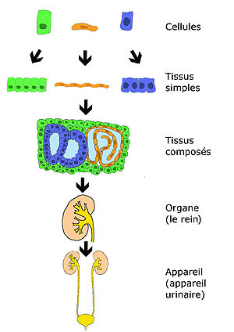

Figure 1 : A classification of tissues in Histology .

**2- ETYMOLOGY OF THE WORD :**

From ancient greek word histo meaning Tissue + Logos meaning study of

**3- A BRIEF HISTORICAL OVERVIEW ABOUT HISTOLOGY :**

Researches agree that the Italian doctor and professor : MARCELLo MALPIGHI is considered as the father of Histology at the 17th century . The development of this filed was due to the invention of microscopes allowing the study of histological sections . in the 19th century, histology was an academic discipline in its own right . The french anatomist Marie Franceois Xavi Bichat introduced the concept of tissue in anatomy in 1801 and the term histology first appeared in a book of Karle Meyer in 1819

**4- BIOLOGICAL TISSUES :**

A/ ANIMAL CLASSIFICATION :

There are four basic types of animal tissues: **muscle tissue** (cells are ready for contraction of tension in our muscles,making it possible to move), **nervous tissue** (it controls the entire working of body)**, connective tissue** (for instance the tissue connects two bones is ligament,even muscles are adheared to the bones with another type is tendon)**,** and **epithelial tissue** (epithelium makes an excellent protective cover for the body). All animal tissues are considered to be subtypes of these four principal tissue types (for example, blood is classified as connective tissue, since the blood cells are suspended in an extracellular matrix, the plasma).

B / PLANT’S CLASSIFICATION :

For plants, the study of their tissues falls under the field of plant anatomy with the following four main types:

• **Dermal tissue :** cells that coat the outer surface of plant’s parts.

**• Vascular tissue :** it transports nutrients within a plant.

**• Ground tissue :** it supports the plant, manufacturates glucose via photosynthesis and stores nutrients.

**• Meristematic tissue :** it allows the growth.