**Eutrophication**

**Ecological impacts**

**Increased** [**algal blooms**](http://www.coastalwiki.org/wiki/Algal_bloom)**:**

[Phytoplankton](http://www.coastalwiki.org/wiki/Phytoplankton) are [photosynthesizing](http://www.coastalwiki.org/wiki/Photosynthesizing) microscopic organisms float in the upper part of water (diatoms, cyanobacteria, and dinoflagellates). In a balanced ecosystem, they provide food for a wide range of organisms

Eutrophication is the presence of high amount of nutrients in water (mainly nitrates and phosphates) mainly from waste water, fertilizers’ runoff, and agro-industry. During eutrophication, phytoplanktons multiply very fast forming [algal blooms](http://www.coastalwiki.org/wiki/Algal_bloom) in freshwater or seawater. Only mall numbers of species are involved and some blooms discolor the water (green, yellow-brown or red) due to high density of pigmented cells. Blooms in the ocean may cover a large area and are easily visible in satellite images.

#### Decreases in water transparency:

The growth of phytoplankton can cause increased [turbidity](http://www.coastalwiki.org/wiki/Turbidity) leading to limited light penetration into the lower depths. In lakes and rivers this can inhibit growth of submerged aquatic plants and affect species fish, shellfish which depend on them.

**Harmful algal blooms:**

[Harmful algal blooms](http://www.coastalwiki.org/wiki/Harmful_algal_bloom) cause harm through the production of toxins or by their accumulated biomass, which can affect occurring organisms and alter food web dynamics as: Human illness, death of fish, birds and mammals following consumption or indirect exposure to toxins, and economic losses to coastal species.

**Water oxygen depletion:**

The death of aquatic plants, and also algae because of their short life cycle cause their decomposition by aerobic bacteria which consume dissolved oxygen, so water can become hypoxic. The direct effects of hypoxia include fish death, which can change fish communities, leading to ecological imbalance. The extreme hypoxic conditions promote the growth of bacteria that produce toxins harmful to birds and animals. Zones where this occurs are called [dead zones](http://www.coastalwiki.org/wiki/Case_studies_eutrophication#Ecological_impacts_of_eutrophication_.28Case_study:_Eutrophication_and_dead_zones.29).

#### Species biodiversity decreases:

Eutrophication causes a shift in the species composition, so that only the more tolerant species survive and new competitive species invade and compete with original inhabitants. Examples is the massive biomass of macroalgae (marine seaweeds), which inhibits the growth of other aquatic plants and algal blooms. Marine seaweeds are recognizable by large blades of algae that may wash up into the shoreline. The seaweed is harmless when it is alive, but when decomposed by anaerobic bacteria, toxic gases such as hydrogen sulfide (H2S)) can be released.

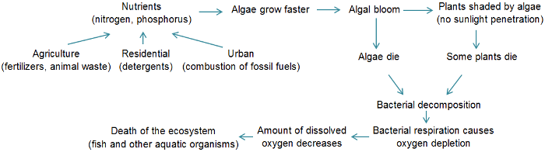

**A diagram showing the causes and the consequences of eutrophication on aquatic ecosystem.**