Badji Mokhtar University - Annaba - Faculty of Sciences - Department of Life and Natural Sciences
The year : 1st year 2019/2020
The field : Biology
The module : Techniques de Communication et d'Expression / Anglais/

BACTERIA AND VIRUSES
( 4 : Grammar Focus : Connctors / Linking Words)
1-WHAT IS A BACTERIUM ?
A bacterium is a microscopic , single-celled organisms that thrives in diverse environments .These organisms can live in soil , the ocean and inside the human gut.
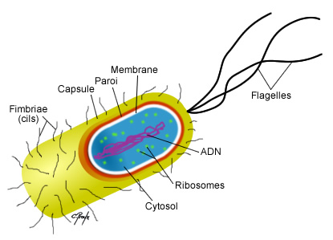
Figure 1: Structure of a bacterium .

2- WHAT IS A VIRUS ?
A virus is a small infectious agent that replicates only inside the living cells of an organism . They can affect all types of life forms , from animals and plants to microoganisms inlcuding bacteria and archaea .
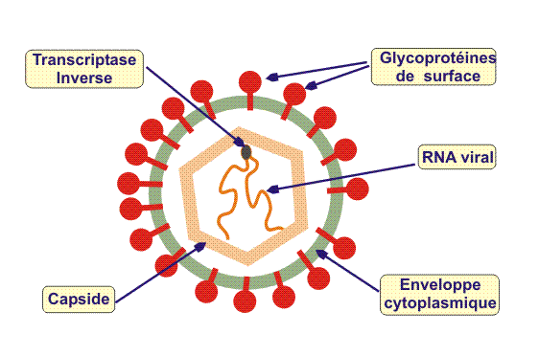
Figure 2: structure of a virus .

3- HOW DO VIRUSES DIFFER FROM BACTERIA?
Viruses ( Like those that cause the flu , or cold , or AIDS) are not made of cells . Although viruses make you sick , just like bacteria do , viruses and bacteria are actually quite different. Viruses are simpler than bacteria and are made of just few molecules . In fact , viruses have so few parts that they can not even grow and divide by themselves ( so they are not considered to be alive). Viruses can only reproduce if they take a host cell and steal its energy and materials .

