Badji Mokhtar University - Annaba - Faculty of Sciences - Department of Life and Natural Sciences
The year : 1st year 2019/2020
The field : Biology
The module : Techniques de Communication et d'Expression / Anglais/
CELL OVERVIEW
( 2- Grammar Focus : Active and Passive Voice)
1-WHAT IS A CELL ?
Cells are sacs of fluid that are reinforced by proteins and surrounded by membranes . Inside the fluid float chemicals and organelles , structures inside cells that are used during metabolic processes . (An organism contains parts that are smaller than a cell , but these structures can not perform all the functions of life on their own , so they are not considered alive ). A cell is the smallest part of an organism that retains characterestics of the entire organism . For example , a cell can take in fuel , convert it to energy , and eliminate wastes , jult like the organism as whole can .
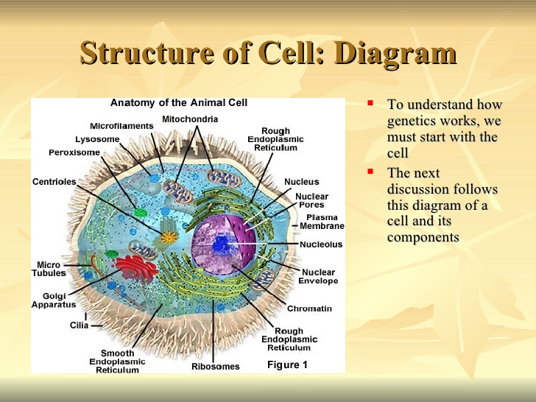
Figure 1 : Structure of a cell .
2-TYPES OF CELLS :
Cells are categorized in different ways , according to structure or function , or in terms of their evolutionary relationship . In term of structure , scientists categorize cells based on their internal organization :
PROKARYOTES : They do not have a 'true' nucleus in their cells like Bacteria and archaea .
EUKARYOTES : They have a nucleus in their cells that houses their genetic material , like plants , animals agae..

